THE ALEXANDER JOSEPH McPHEE FAMILY OF VERMILION

Alexander Joseph McPhee's father was the first in the family to sail for Canada. He finally settled and built a home at Markdale, Bruce County, Ontario. It is said that Alexander's father was a magistrate in Glasgow.
A master craftsman from the famous shipyards of Glasgow, Scotland, this ingenious builder constructed his house at Markdale to look like a ship. One can imagine his watching his fields from one of its "portholes" as he planned the season's plantings and harvests with his wife, who spoke only Gaelic. Alexander's wife died in 1921.
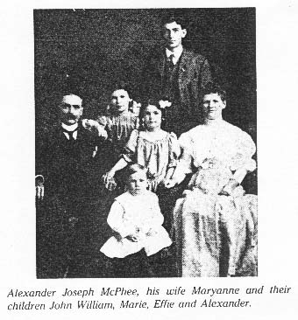
Their grandson, John William, son of Alexander Joseph McPhee and Mary Anne Fitzmaurice, was born in Hamilton, Ontario, so we presume that Alexander Joseph left the Markdale farm. Mrs. John William McPhee relates that her father-in-law, Alexander Joseph, was the oldest in the family but that he did not enjoy farming. He eventually became a salesman in Ontario for a chocolate company. This experience in selling helped when he came west (about 1910) and became the agent for John Deere Company in Vermilion. Alexander Joseph later rented a farm near Vermilion to keep the family living together as Effie Irene, his daughter, was teaching at Wildwood School, a few miles out of Vermilion.
It was amazing that he did not enjoy farming in Bruce County, Ontario, yet would homestead in the northern wilderness of Alberta. Grandson Bill says, "He was a better salesman than farmer".
John William, better known as Jack, was fourteen years older than the eldest of the other three children. Needless to say he was a bit of an "idol" to the members, so, when he became District Manager of Alberta Government Telephones (all of Northern Alberta) in Grande Prairie, the family moved from Vermilion to take up homestead land within walking distance of the telephone office in Grande Prairie.
Effie was persuaded by her older brother to give up teaching and become the Chief Telephone Operator and A.G.T. Agent for the town and surrounding district.
Alexander stayed in Ontario and had a lifetime career with the C.N.R. until his death in Toronto in 1955. Sarah Marie married in the early 1920's and moved to Chicago where she lived out her life.
Effie Irene Margaret married Charles Field and they lived in Grande Prairie until Charlie joined the R.C.A.F. at the outbreak of the Second World War. In 1942, Charlie was the victim of an air explosion off the British Columbia coast; all on board were lost. Effie raised her two daughters, working occasionally to supplement the sparse army pension.
After Amy Marie and Eileen Margaret were married, Effie chose to go to Chicago and live with her sister. A mutual need was well served by this arrangement for nine years, until the death of Sarah Marie in 1978. Effie's health was not the best, so, she returned to Edmonton where care and medical attention has brought her back to being a very chipper and happy lady. Effie, at 83 years of age, has many a story of her three grandchildren.

JOHN WILLIAM McPHEE OF EDMONTON Arrived 1910
John William, son of Alexander Joseph McPhee and Mary Anne Fitzmaurice, was born in Hamilton, Ontario on August 29th 1886. He married Florence Redig of Lacombe in 1919.
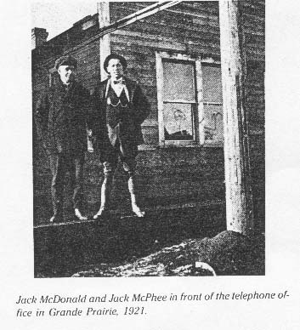
John William worked for Bell Telephone in Ontario for six years before coming to Edmonton, Alberta in 1910, where he was employed with Alberta Government Telephones and continued with A.G.T. until his retirement in 1951.
This means that he began as a "telephone man" in1904 - a real telephone pioneer. The Bell Company, first telephone company in the world, was in its infancy in 1904, having been founded by Alexander Graham Bell in 1877.
John's wife, Florence Redig, writes that she and John William moved to Grande Prairie in 1920 after their marriage in Lacombe in 1919. Their first three children were born there, the fourth child in Lacombe and the last in Taber.
A son, William Kent of Calgary, tells that after corning to Edmonton, John William labored on telephone lines east of Edmonton where they used horses and wagons to carry construction equipment.

Like many communities of the time, Grande Prairie and Peace River each had local telephone communications but there was no line connecting the towns. They used North Alberta Railroad Telegraph to send messages from town to town. It was under John William, as local manager at Grande Prairie, that the first telephone line between there and Peace River was constructed. This progressive man later became a member of the Telephone Pioneer Operators of America. One became a pioneer by the length of time employed.
When John and his family transferred to Taber to fill his appointment as manager in 1926, the rural systems were a poorly managed and operated system of "mutual" lines which were owned by the farmers who used the line. Shortly after, these were tied into the A.G.T. system.
William Kent (Bill) remembers that these rurals were often in "bad repair". Sometimes, if the wires or poles went down in a storm, they were connected to the barbwire fencing until the farmer in charge of repairs had time to correct the damage. He also tells how, as a boy, he helped his Dad on a trouble-shooting trip on the line between Taber and Retlaw. It turned out that the problem was caused when some fun-loving cowboys had killed rattle snakes and hung them up over the phone wires. Young Bill stayed in the car while his Dad climbed a pole and shook the snakes down. He said that he wouldn't get out of that car for anything!
He recalls that the southeast country was pretty desolate then. A phone man could easily get lost in a winter storm, and even in the hot summers, a breakdown in his old Series 4 Model T could leave him stranded miles from anyone. He eventually used a motorcycle to do his trouble-shooting and in later years, John William traveled in a Chevy truck.
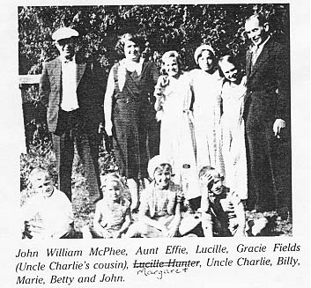
Many readers will remember how, as little children, we watched, fascinated, while the telephone man "walked up" the poles like a mountain climber - slapping the sharp, tinkling spurs into the soft cedar of the phone pole. He then leaned far out from the pole against the leather strap, which encircled both climber and pole while he made the repairs. For the uninitiated, these spurs were buckled onto the leg and the 2 1/2 inch sharp-pointed spurs protruded at the instep from stirrups which were fastened to the climber's foot.
When we were very young, we didn't see the shiny spurs and we thought the man was magic. Later, we argued about whether he had "pointed things" on his feet or not. Strange that we never thought of asking the telephone man but children in those days were to be seen and not heard. Bill still retains his little-boy admiration for the brave dad who climbed the poles using only ”spurs".
By 1930, the depression had hit and we can assume that John William was one of the suddenly unpopular telephone men who had to go from house to house removing the telephones of people who hadn't the money to pay their phone bills.

